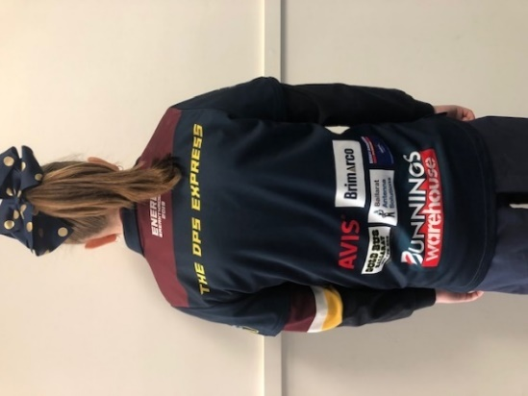

**Your company’s name and logo as the naming rights sponsor.**

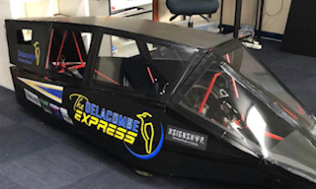

**What else do you receive?**

* **Prime positioning on our school website.**
* **Advertising on our social media channels and fortnightly school newsletter.**
* **Team shirt.**
* **Framed team photo.**
* **Invitation to our annual volunteer’s morning tea.**
* **Invitation to our school’s marquee on race day.**

**Your company’s name and logo as our HPVs naming rights. sponsor.**

**Large image of your company’s logo.**